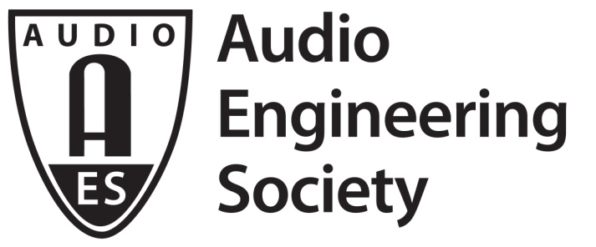

PRESS RELEASE
Contact: Robert Clyne
robert.clyne@aes.org
Tel: (615) 662-1616 x17

FOR IMMEDIATE RELEASE

AES New York Convention Advance Registration Opens

New York, NY, May 17, 2017 — The Audio Engineering Society has opened online advance registration for its 143rd International AES Convention, taking place October 18 to 21, 2017, at the Jacob Javits Center in New York City. The largest professional audio education, networking and gear exhibition of the year, this fall’s AES Convention will offer a comprehensive and expansive professional media and entertainment production program, three full days of pro audio gear exhibitions and presentations, and a world-class series of events and experiences to take attendees to the next level of audio prowess.

Not only does advance registration offer the lowest pricing available on technical program All Access badges, but, for the 30 days prior to June 17, Exhibits-Plus registration is complimentary – a $75 value. In addition, AES New York 2017 will be co-located with the NAB Show New York 2017. Registration, at any level, for AES New York 2017 will give attendees access to the NAB Show New York exhibition floor and the content in the NAB Show New York’s Core Package (also a $75 value). In an increasingly multimedia-driven world, the 300+ exhibitors expected to showcase video production tools on the NAB Show New York exhibition floor will complement the 300+ professional audio exhibitors that are regulars on the AES New York exhibition floor, offering media professionals the potential for a broader experience.

“AES Conventions have a rich tradition of driving progress in audio technology and application, notes AES Executive Director Bob Moses. “While this year’s convention takes place alongside the NAB Show New York, it remains an independent gathering of a global community of audio professionals and students – end users, manufacturers, researchers and scientists. The NAB Show New York is focused on the production and distribution of mainly video content. It's a natural fit that these two organizations collaborate and cross-pollinate, developing new workflows and business models and creating new opportunities for our communities.”

The full four-day AES New York 2017 technical program lets attendees Listen, Learn and Connect via presentations covering the latest audio research and via workshops, tutorials, technical tours, and student and career development events spanning a diverse array of audio topics, all led by the world's leading audio experts. This year’s AES New York convention will also feature an expanded program of special events and exhibition floor stage presentations – ranging from broadcast audio to recording, live sound, virtual reality and more – open to all attendees. Full program details are in development now. Visit www.aesshow.com to see what’s in store and register today for the ultimate pro audio experience, AES New York 2017.

...ends 424 words

Photo File: AES_NY.JPG
Photo Caption: AES New York: Maximum Audio

About the Audio Engineering Society
The Audio Engineering Society was formed in 1948 and now counts over 12,000 members throughout the U.S., Latin America, Europe, Japan and the Far East. The organization serves as the pivotal force in the exchange and dissemination of technical information for the industry. Currently, its members are affiliated with more than 75 AES professional sections and more than 95 AES student sections around the world. Section activities may include guest speakers, technical tours, demonstrations and social functions. Through local AES section events, members experience valuable opportunities for professional networking and personal growth. For additional information visit http://www.aes.org.

Join the conversation and keep up with the latest AES News and Events:
Facebook: http://facebook.com/AES.org
Twitter: #AESorg (AES Official)

AES Marketing Communications:
Email: robert.clyne@aes.org
Tel: 615-662-1616, Fax: 615-662-1636,
Clyne Media, Inc.,
169-B Belle Forest Circle, Nashville, TN 37221;
Web: http://www.clynemedia.com

