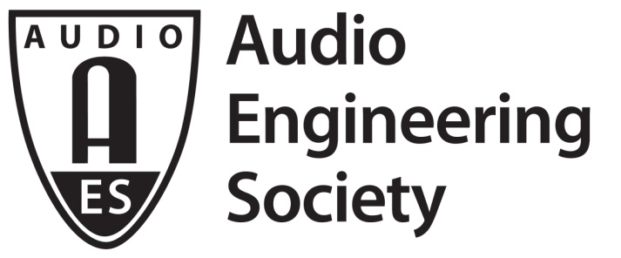 | PRESS RELEASE  Conference contacts:  Co-Chair Andres Mayo  2016avar_chairs@aes.org | +54 (11) 4718-1234  Co-Chair Linda Gedemer  linda@sourcesound.com | +1 818.943-5706

FOR IMMEDIATE RELEASE

AES to Hold First International Conference on
Audio for Virtual and Augmented Reality

— Conference to focus on VR/AR creative process, applications workflow and product development —

New York, NY, May 16, 2016 — The inaugural AES International Conference on Audio for Virtual and Augmented Reality, to be held on September 30 and October 1, 2016, will be co-located with the 141st AES Convention at the Los Angeles Convention Center’s West Hall. The two-day program of technical papers, workshops, tutorials and a manufacturer’s expo will throw a unique spotlight on the creative and technical challenges of providing immersive spatial audio to accompany virtual-reality and augmented-reality media, which is demonstrably the fastest-growing section of the entertainment-audio markets.

The conference will attract content developers, researchers, manufacturers, consultants and students, in addition to audio engineers seeking to expand their knowledge about sound production for virtual and augmented reality. The companion Expo will feature displays from leading-edge manufacturers and service providers looking to secure industry metrics for this emerging field.

“Film director George Lucas once stated that sound represents 50% of the motion-picture experience,” considers co-chair Andres Mayo. “This conference will demonstrate that convincing VR and AR productions, using a variety of playback devices, require audio that follows the motions of the subject, and produce a realistic immersive experience. Our program will spotlight the work of leading proponents in this exciting field of endeavor, and how realistic spatial audio can be produced from existing game-console and DSP engines.”

The rich and varied conference program will provide an overview of the VR/AR creative process, applications workflow and product development, while creating an activity hub to focus attention on the expertise the Audio Engineering Society can offer these expanding creative communities. Costs range from $195 for a 1-Day Pass for AES members ($295 for a 2-Day Pass) and $125 for accredited students, to $280/$435 for non-members; early-bird discounts also are available.

Proposed topics include: Object-based Audio Mixing for VR/AR Applications; Immersive Audio in VR/AR Broadcast; Live VR Audio Production; Developing Audio Standards for VR/AR Applications; Cross Platform Audio Considerations in VR Applications; and Streaming Immersive Audio Content.

This must-attend conference will be held within a recently-remodeled 300-seat theater and companion seminar room at the LA Convention Center. A unique entrance from the main convention lobby will offer a dedicated attendee registration check-in and related facilities. Conference registrants can also attend the 141st AES Convention’s companion exhibition and select educational sessions and special events free of charge with an Exhibits-Plus badge.

For further information on the 2016 International Conference Audio for Virtual and Augmented Reality, visit http://www.aes.org/conferences/2016/avar/. Follow us on Twitter (https://twitter.com/audioforvr) and Facebook (http://bit.ly/1R4leDI). For more about the 141st Audio Engineering Society International Convention in Los Angeles, visit http://www.aes.org/events/141/. Find out more about the Audio Engineering Society at aes.org.

...ends 458 words

Photo File: 2016AVAR.jpg
Photo Caption: Logo for AES AVAR Conference

About the Audio Engineering Society
The Audio Engineering Society was formed in 1948 and now counts over 14,000 members throughout the U.S., Latin America, Europe, Japan and the Far East. The organization serves as the pivotal force in the exchange and dissemination of technical information for the industry. Currently, its members are affiliated with more than 75 AES professional sections and more than 95 AES student sections around the world. Section activities may include guest speakers, technical tours, demonstrations and social functions. Through local AES section events, members experience valuable opportunities for professional networking and personal growth. For additional information visit http://www.aes.org.

Join the conversation and keep up with the latest AES News and Events:
Twitter: #AESorg (AES Official) | Facebook: http://facebook.com/AES.org

AES Marketing Communications:
Email: robert.clyne@aes.org
Tel: 615-662-1616, Fax: 615-662-1636,
Clyne Media, Inc.,
169-B Belle Forest Circle, Nashville, TN 37221;
Web: http://www.clynemedia.com

