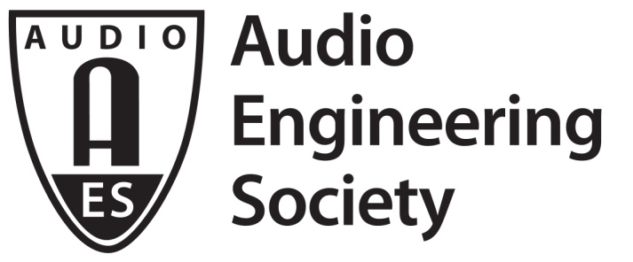

FOR IMMEDIATE RELEASE

Get Connected with the Latest in Audio Networking Technology
and Standards at AES New York 2018

— Broad range of seminars to cover topics from network fundamentals for audio engineers to the latest advancements in AES67, ST 2110 and other emerging standards and protocols —

New York, NY, September 28, 2018 — As audio signal delivery migrates from traditional cabling to media networks, the AES New York 2018 Networked Audio Track will “highlight the practical aspects of designing, building, and using networked audio systems,” states the Convention’s Networked Audio Track chair Bob Lee. “Much of what we used to do in the analog realm — along with many, many things that we wished we could do — has now become routine and commonplace with media over digital networks, and with reduced costs and reduced physical infrastructure requirements.” The 145th Audio Engineering Society International Convention, being held October 17 – 20 at NYC’s Jacob Javits Center, will include a series of workshops, tutorials and research paper presentations ranging from a course in networking fundamentals for audio engineers to the latest developments in standards and real-world practices. “A lot of us audio engineers are old dogs who have to learn new tricks as we add IT to our skill set,” Lee continues. “And the audio engineers starting out just as well need to learn about the kinds of systems they'll be called upon to work with.” These sessions, along with hundreds more, are available exclusively with AES New York 2018 All Access registration.

Two standards having a significant impact on media networking are AES67 (for audio over IP interoperability) and SMPTE ST 2110 (which addresses audiovisual content over IP). The “Interoperability Standards for IP Media Networking” session will review the background behind these standards, outline their objectives, examine the relationship between the two and explore a roadmap for the future. The “Real World AES67” workshop and Q&A session will address the benefits and challenges of implementing AES67 and ST 2110-30 in the field, with an emphasis on the broadcast market.

For product developers and designers, the session “How to Get AES67 Into Your Systems or Products” will point out options currently available, including modules, software libraries and reference designs. The workshop will also consider the value of offering AES67 compatibility from the perspective of existing AoIP networking solutions providers. The workshop is targeted towards product manufacturers but should also provide valuable insight to anyone with a general technical interest in AES67.

Another seminar, “AES67 and Corresponding SMPTE Standards,” will host a panel of industry experts who will further examine the AES67, ST 2110 and also ST 2022 protocols and discuss methods for achieving the best-possible results using these standards. The session “A/V Fiber Optic Connectors, Selection and Terminations” will show attendees all they need to know about selecting, using and terminating fiber optic connectors and the ways in which these connectors can affect the signals in an A/V system.

Created by Pro AV market leaders in the Avnu Alliance, the Milan protocol supports interoperability at the application layer and is cited by its creators as the first tangible solution to combine the technical benefits of the AVB standard with Pro AV market-defined device requirements at both the network and application layer. “Milan: The New Application Layer Protocol for Open-Standard AVB Networks” will offer background on this new protocol and share its developer’s vision for reliable, future-proof delivery of networked media.

Additional AES New York Networked Audio Track sessions will include “Network Fundamentals for Audio Engineers,” which will serve as an introductory course for everyone who wants to get up to speed on audio over IP. Expanding upon the concept, “Optimizing Networks for Audio” will discuss best practices for transmitting audio over IP and achieving the most efficient means of configuring and implementing networked audio systems.

The Networked Audio Track events are only available with All Access registration to AES New York 2018 – All Access registration is the ticket to everything the Convention has to offer. Advance registration is open now at aesshow.com. AES Members, including student members, enjoy substantial discounts on All Access registration. Registration at any level for AES New York 2018 includes access to the NAB Show New York exhibition. AES New York 2018 Exhibits-Plus registration is complimentary for AES Members and those using the VIP code “AES18NOW” at checkout. If it’s about audio, it’s at AES – the ultimate opportunity for audio professionals of all specialties, and future audio pros, to listen, learn and connect!

...ends 690 words

Photo File: Lee.JPG
Photo Caption: AES New York Convention Networked Audio Track chair Bob Lee

About the Audio Engineering Society
The Audio Engineering Society, celebrating its 70th anniversary in 2018, now counts over 12,000 members throughout the U.S., Latin America, Europe, Japan and the Far East. The organization serves as the pivotal force in the exchange and dissemination of technical information for the industry. Currently, its members are affiliated with 90 AES professional sections and more than 120 AES student sections around the world. Section activities include guest speakers, technical tours, demonstrations and social functions. Through local AES section events, members experience valuable opportunities for professional networking and personal growth. For additional information visit aes.org.

Join the conversation and keep up with the latest AES News and Events:
Twitter: #AESorg (AES Official)
Facebook: facebook.com/AES.org

AES Marketing Communications:
Email: robert.clyne@aes.org
Tel: 615-662-1616, Fax: 615-662-1636,
Clyne Media, Inc.,
169-B Belle Forest Circle, Nashville, TN 37221;
Web: http://www.clynemedia.comX

