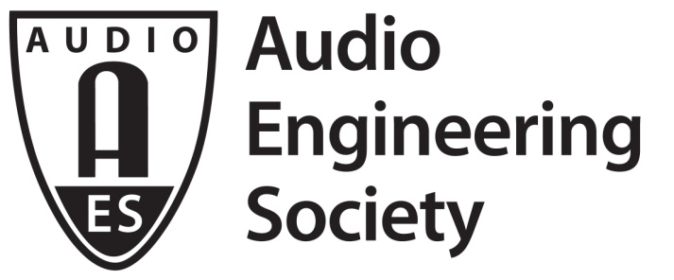

PRESS RELEASE
Contact: Robert Clyne
robert.clyne@aes.org
Tel: (615) 662-1616 x17

FOR IMMEDIATE RELEASE

139th International AES Convention’s Product Development Track Set to Spotlight the Industry’s Latest Advancements in Product Design

— Digital loudspeaker signal processing, advanced sound system measurement techniques and much more will be presented at in-depth sessions —

New York, NY, October 8, 2015 — Audio technology continues to move forward ever faster, and the 139th AES International Convention’s Product Development Track will offer a detailed look at the latest advancements in product design and development engineering. The seminars will take place at the 139th AES Convention at the Jacob Javits Center in New York, October 29 – November 1.

“Our Product Development Track will bring leading design professionals together to address a broad range of critical issues within the R and D community,” said Scott Leslie of Ashly Audio, presenter of the upcoming “Optimizing the Powered Loudspeaker System” session and PD Track chairman. “These sessions will dig deep into some of the most important considerations facing audio design professionals today.”

The Product Development Track seminars will include the following:

Thursday, October 29, 9:00 – 10:30 am
“Almost Everything You Ever Wanted to Know About Loudspeaker Design”
Presenter: Christopher Struck, CJS Labs

Thursday, October 29, 10:45 am – 12:15 pm
Practical Loudspeaker Processing for the Practicing Engineer
Presenter: Paul Beckmann, DSP Concepts

Thursday, October 29, 2:15 – 3:45 pm
Designing for Ultra-Low THD+N In Analog Circuits, Circa 2015
Presenter: Bruce E. Hofer, Audio Precision, Inc.

Thursday, October 30, 4:00 – 5:30 pm
Electrical and Mechanical Measurement of Sound System Equipment
Presenter: Wolfgang Klippel, Klippel GmbH

Friday, October 30, 9:00 – 10:30 am
Best Practices In Production Test
Presenter: Jonathan Novick, Audio Precision

Friday, October 30, 10:45 am – 12:15 pm
What Happens In A Patent Lawsuit
Presenter: John Strawn, S Systems Inc.; Tom Millikan, Perkins Coie LLP

Saturday, October 31, 9:00 – 10:30 am
Modern Digital Processing of Microphone Signals
Presenter: Paul Beckmann, DSP Concepts

Saturday, October 31, 10:45 am – 12:15 pm
Adaptive Loudspeaker Control – An Application Tutorial
Presenter: Gregor Hoehne, Klippel GmbH

Saturday, October 31, 2:45 – 4:15 pm
Creating High-Resolution Modeling Data for Loudspeakers and Line Arrays
Presenter: Stefan Feistel, AFMG Technologies GmbH

Saturday, October 31, 4:30 – 6:00 pm
Optimizing the Powered Loudspeaker System
Presenter: Scott Leslie, Ashly Audio

Sunday, November 1, 9:00 – 10:30 am
Loudspeaker Measurements
Presenter: Charles Hughes, Excelsior Audio and AFMG Technologies

Sunday November 1, 10:45 am – 12:15 pm
The Past, Present and Future of Coaxial and Related Transducers
Presenter: Steven Hutt, Equity Sound Investments

Additional information about the AES Product Development Track is available at: http://www.aes.org/events/139/productdevelopment/?displayall.

For the latest information on the 139th Audio Engineering Society International Convention in New York City and how to register for your FREE Exhibits-Plus or premium All Access badge, visit http://www.aes.org/events/139/.

...ends 399 words
Photo File: Product_Development.JPG
Photo Caption: 139th International AES Convention Product Development Track

About the Audio Engineering Society
The Audio Engineering Society was formed in 1948 and now counts over 14,000 members throughout the U.S., Latin America, Europe, Japan and the Far East. The organization serves as the pivotal force in the exchange and dissemination of technical information for the industry. Currently, its members are affiliated with more than 75 AES professional sections and more than 95 AES student sections around the world. Section activities may include guest speakers, technical tours, demonstrations and social functions. Through local AES section events, members experience valuable opportunities for professional networking and personal growth. For additional information visit http://www.aes.org.

AES Marketing Communications:
Email: robert.clyne@aes.org
Tel: 615-662-1616, Fax: 615-662-1636,
Clyne Media, Inc.,
169-B Belle Forest Circle, Nashville, TN 37221;
Web: http://www.clynemedia.com

